**Faculty of Engineering at Shoubra**

**Computer (ECE001)**

**Final Project**

Project Topic: **Internet of Things (IOT)**

Name: **Ahd Youssef Omar (B.N/560)**

**GitHup:** [**https://ahdyoussef.github.io/ece001/**](https://ahdyoussef.github.io/ece001/)

**Application brief :**

In my project I used **Visual Studio Code** to code with html. Its easy to use and to edit with it.

**Visual Studio Code** also offer up suggestions for elements, tags, some values (as defined in HTML5), Ionic and AngularJS tags.

**Screenshots :**

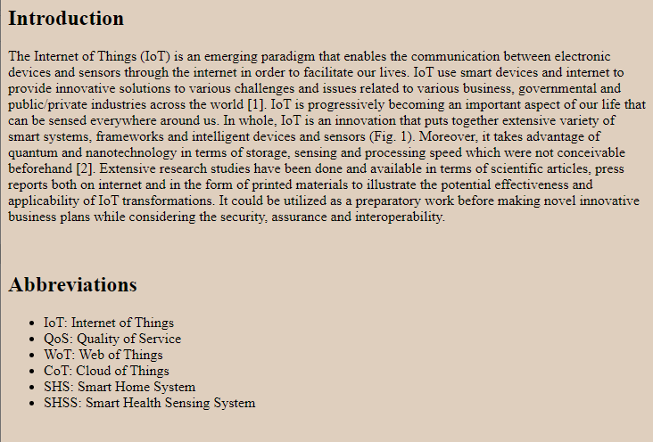

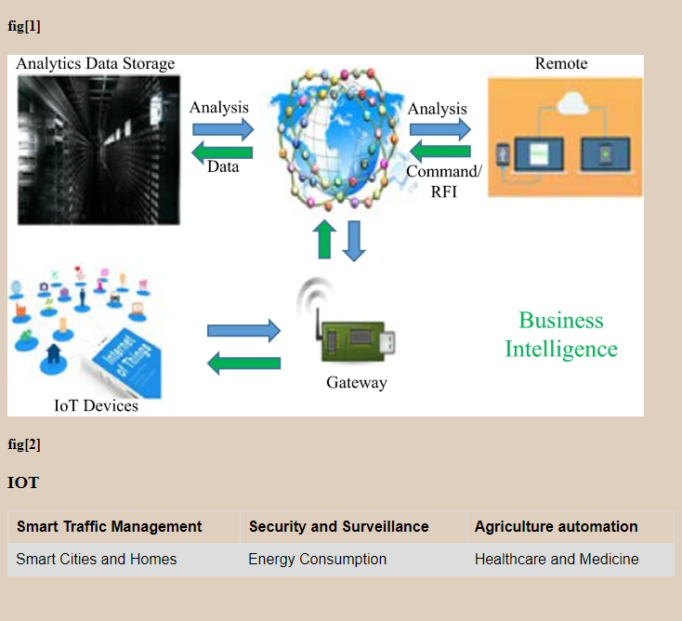

**Source Code :**

